**Java Inheritance**

Inheritance is one of the key features of OOP that allows us to create a new class from an existing class.

The new class that is created is known as **subclass** (child or derived class) and the existing class from where the child class is derived is known as **superclass** (parent or base class).

The extends keyword is used to perform inheritance in Java. For example,

class Animal {

// methods and fields

}

// use of extends keyword

// to perform inheritance

class Dog extends Animal {

// methods and fields of Animal

// methods and fields of Dog

}

In the above example, the Dog class is created by inheriting the methods and fields from the Animal class.

Here, Dog is the subclass and Animal is the superclass.

**Example 1: Java Inheritance**

class Animal {

// field and method of the parent class

String name;

public void eat() {

System.out.println("I can eat");

}

}

// inherit from Animal

class Dog extends Animal {

// new method in subclass

public void display() {

System.out.println("My name is " + name);

}

}

class Main {

public static void main(String[] args) {

// create an object of the subclass

Dog labrador = new Dog();

// access field of superclass

labrador.name = "Rohu";

labrador.display();

// call method of superclass

// using object of subclass

labrador.eat();

}

}

[Run Code](https://www.programiz.com/java-programming/online-compiler)

**Output**

My name is Rohu

I can eat

In the above example, we have derived a subclass Dog from superclass Animal. Notice the statements,

labrador.name = "Rohu";

labrador.eat();

Here, labrador is an object of Dog. However, name and eat() are the members of the Animal class.

Since Dog inherits the field and method from Animal, we are able to access the field and method using the object of the Dog.

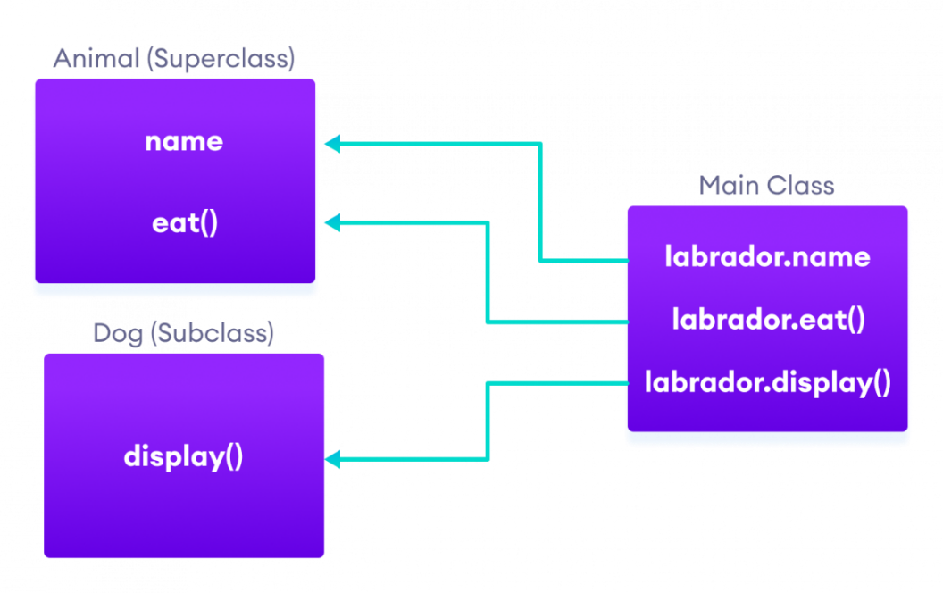Java Inheritance Implementation

**is-a relationship**

In Java, inheritance is an **is-a** relationship. That is, we use inheritance only if there exists an is-a relationship between two classes. For example,

* **Car** is a **Vehicle**
* **Orange** is a **Fruit**
* **Surgeon** is a **Doctor**
* **Dog** is an **Animal**

Here, **Car** can inherit from **Vehicle**, **Orange** can inherit from **Fruit**, and so on.

**Method Overriding in Java Inheritance**

In **Example 1**, we see the object of the subclass can access the method of the superclass.

**However, if the same method is present in both the superclass and subclass, what will happen?**

In this case, the method in the subclass overrides the method in the superclass. This concept is known as method overriding in Java.

**Example 2: Method overriding in Java Inheritance**

class Animal {

// method in the superclass

public void eat() {

System.out.println("I can eat");

}

}

// Dog inherits Animal

class Dog extends Animal {

// overriding the eat() method

@Override

public void eat() {

System.out.println("I eat dog food");

}

// new method in subclass

public void bark() {

System.out.println("I can bark");

}

}

class Main {

public static void main(String[] args) {

// create an object of the subclass

Dog labrador = new Dog();

// call the eat() method

labrador.eat();

labrador.bark();

}

}

[Run Code](https://www.programiz.com/java-programming/online-compiler)

**Output**

I eat dog food

I can bark

In the above example, the eat() method is present in both the superclass Animal and the subclass Dog.

Here, we have created an object labrador of Dog.

Now when we call eat() using the object labrador, the method inside Dog is called. This is because the method inside the derived class overrides the method inside the base class.

This is called method overriding. To learn more, visit [Java Method Overriding](https://www.programiz.com/java-programming/method-overriding).

**Note**: We have used the @Override annotation to tell the compiler that we are overriding a method. However, the annotation is not mandatory. To learn more, visit [Java Annotations](https://www.programiz.com/java-programming/annotations).

**super Keyword in Java Inheritance**

Previously we saw that the same method in the subclass overrides the method in superclass.

In such a situation, the super keyword is used to call the method of the parent class from the method of the child class.

**Example 3: super Keyword in Inheritance**

class Animal {

// method in the superclass

public void eat() {

System.out.println("I can eat");

}

}

// Dog inherits Animal

class Dog extends Animal {

// overriding the eat() method

@Override

public void eat() {

// call method of superclass

super.eat();

System.out.println("I eat dog food");

}

// new method in subclass

public void bark() {

System.out.println("I can bark");

}

}

class Main {

public static void main(String[] args) {

// create an object of the subclass

Dog labrador = new Dog();

// call the eat() method

labrador.eat();

labrador.bark();

}

}

[Run Code](https://www.programiz.com/java-programming/online-compiler)

**Output**

I can eat

I eat dog food

I can bark

In the above example, the eat() method is present in both the base class Animal and the derived class Dog. Notice the statement,

super.eat();

Here, the super keyword is used to call the eat() method present in the superclass.

We can also use the super keyword to call the constructor of the superclass from the constructor of the subclass. To learn more, visit [Java super keyword](https://www.programiz.com/java-programming/super-keyword)**.**

**protected Members in Inheritance**

In Java, if a class includes protected fields and methods, then these fields and methods are accessible from the subclass of the class.

**Example 4: protected Members in Inheritance**

class Animal {

protected String name;

protected void display() {

System.out.println("I am an animal.");

}

}

class Dog extends Animal {

public void getInfo() {

System.out.println("My name is " + name);

}

}

class Main {

public static void main(String[] args) {

// create an object of the subclass

Dog labrador = new Dog();

// access protected field and method

// using the object of subclass

labrador.name = "Rocky";

labrador.display();

labrador.getInfo();

}

}

[Run Code](https://www.programiz.com/java-programming/online-compiler)

**Output**

I am an animal.

My name is Rocky

In the above example, we have created a class named Animal. The class includes a protected field: name and a method: display().

We have inherited the Dog class inherits Animal. Notice the statement,

labrador.name = "Rocky";

labrador.display();

Here, we are able to access the protected field and method of the superclass using the labrador object of the subclass.

**Why use inheritance?**

* The most important use of inheritance in Java is code reusability. The code that is present in the parent class can be directly used by the child class.
* Method overriding is also known as runtime polymorphism. Hence, we can achieve Polymorphism in Java with the help of inheritance.

**Types of inheritance**

There are five types of inheritance.

**1. Single Inheritance**

In single inheritance, a single subclass extends from a single superclass. For example,

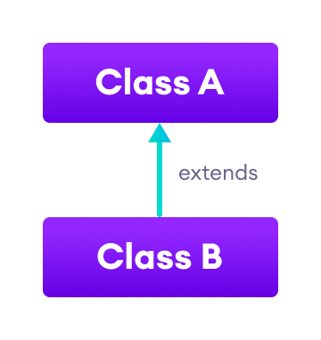Java Single Inheritance

**2. Multilevel Inheritance**

In multilevel inheritance, a subclass extends from a superclass and then the same subclass acts as a superclass for another class. For example,

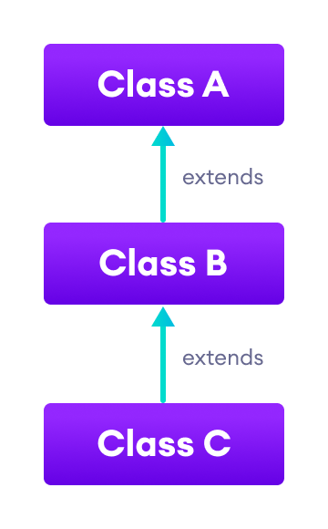Java Multilevel Inheritance

**3. Hierarchical Inheritance**

In hierarchical inheritance, multiple subclasses extend from a single superclass. For example,

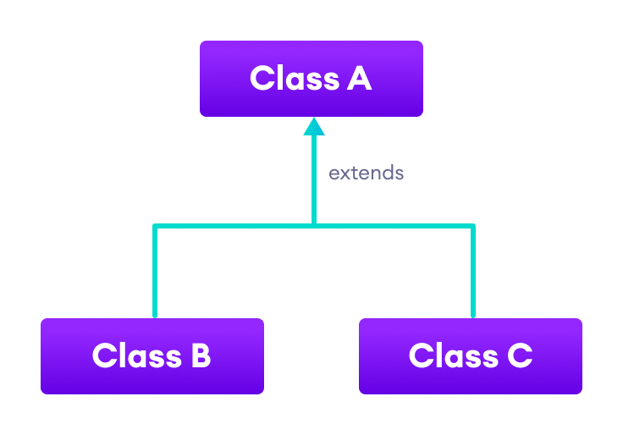Java Hierarchical Inheritance

**4. Multiple Inheritance**

In multiple inheritance, a single subclass extends from multiple superclasses. For example,

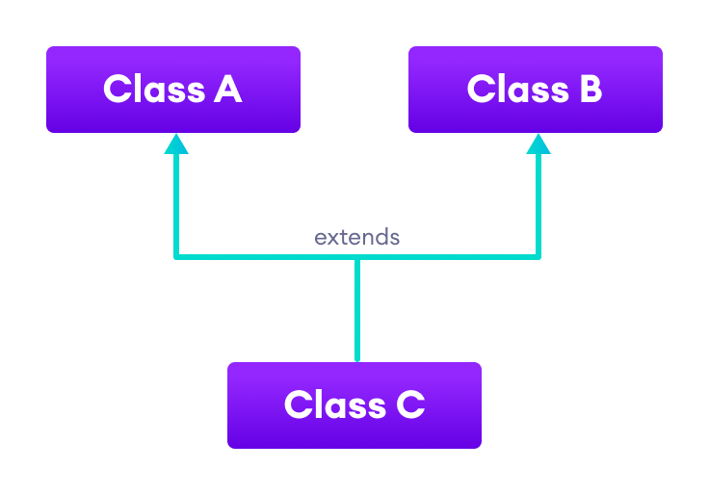Java Multiple Inheritance

**Note**: Java doesn't support multiple inheritance. However, we can achieve multiple inheritance using interfaces. To learn more, visit [Java implements multiple inheritance](https://www.programiz.com/java-programming/examples/implement-multiple-inheritance).

**5. Hybrid Inheritance**

Hybrid inheritance is a combination of two or more types of inheritance. For example,

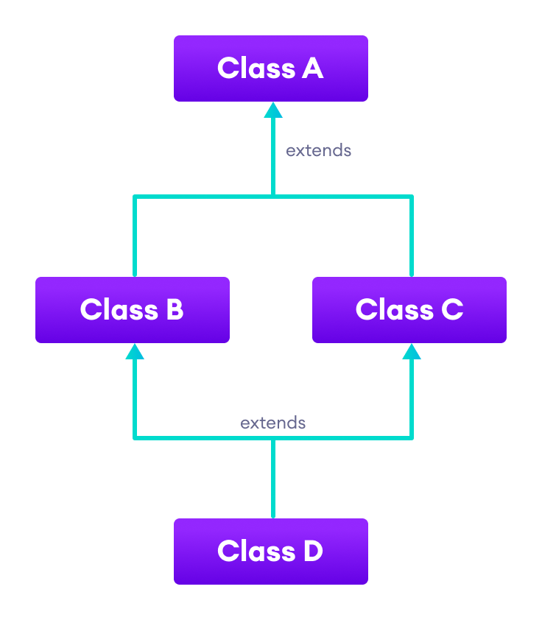Java Hybrid Inheritance

Here, we have combined hierarchical and multiple inheritance to form a hybrid inheritance.